Welcome to history through art, where we examine some of the most iconic artworks in under ten minutes. I’m the host, Minjeong, and in this episode, we’ll be looking at Washington Crossing the Delaware by Emanuel Leutze. While listening to this podcast, it’ll be easier to follow what I’m referencing if you have a visual guide. So, there will be a corresponding blog with all the images linked in the transcripts.
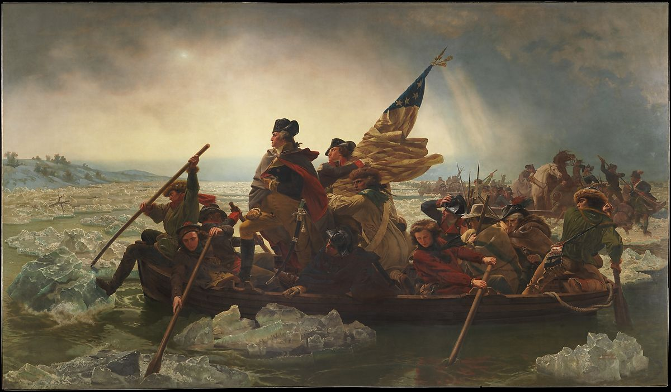
Looking at the painting itself, this is a scene of Washington and the Continental Army crossing the Delaware River on Christmas day, in the year 1776, to surprise the British Hessian troops in Trenton, New Jersey. The first thing that you’ll notice when you see this painting, is that it’s painted in darker, muted tones that seem to reflect the dreariness of the weather and the fatigue from battles. There are boats that are heading leftwards of the painting, towards the light source, which is Trenton.
In the boat closest to us, there’s a central figure standing slightly to the left of the painting. That’s George Washington. He’s looking still and determined, while the rest of the army is in motion rowing across the icy river. He is raised just one head above everyone else, and if you look, there’s a halo formed around his head from that light source. Also notice how the oars that the men are using are oriented; they are diagonals, in line with the flag; it seems to be framing Washington, highlighting and drawing our eyes to him.
Now let’s take a look at other people that are in the boat with him. There are twelve people including Washington. Right next to him is Lieutenant James Monroe, who became the fifth president of the United States, holding the U.S. flag. The other ten soldiers each symbolize unique backgrounds that the continental army was comprised of. There are farmers from the North wearing wide brimmed hats and a Native American with his bandolier bag; there’s a Scottish immigrant wearing a Balmoral bonnet and a countryman from the West. There is an African American soldier and an androgynous rower dressed in red, who could’ve possibly been a female.
So we have all these different types of people here in one boat, and Leutze wanted to show Washington charismatically leading this diverse group to the victory at the Battle of Trenton.
---Historical Context---
Now, the Battle of Trenton was significant because up to that point, the Continental Army had been losing a lot of battles. So this one victory gave a huge morale boost and inspired others to enlist in the Army, and eventually led to other subsequent victories.
Let’s examine how the crossing of the Delaware actually happened. General Washington’s original plans were to divide his army into three groups, and to approach Trenton from three different sides to trap the Hessian army. The largest group, led by Washington, would have attacked from the north, and the other two would have blocked the escape and diversion routes that the Hessian army could have taken. It was a solid plan, until the midnight of the crossing when the weather became bad and the other two groups couldn’t cross the river. The icy river that night was fast, and although it was only 800 feet of crossing distance and the river itself was about 90 inches deep, most of the men in the army did not know how to swim. But Washington’s contingent was able to cross without losing anyone with the help from local watermen to navigate the river in the dark. The group’s horses and artillery safely crossed as well. In the morning, the other two groups crossed the river, and together attacked the Hessian troops, who were still groggy from Christmas feasts from the previous night. Between 1,400 Hessian soldiers vs. 5,400 Washington’s soldiers, it was a clear victory for the Continental Army.
---Historical Analysis, Significance---
So this painting was painted by an artist named Emanuel Leutze. Leutze was born in Germany in 1816, and was raised in Philadelphia. He later returned to Europe, where he witnessed the German Revolution of 1848. Now, Leutze was always interested in this idea of “political freedom” and often showed it in his paintings, mostly his 1840s paintings. So, in response to and to show support for this German revolution, he began this painting in 1850 with the inspirations from the democratic principles he got during his stay. In his mind, the image of the young America contrasted with the despotic European rule, which explains the overtly heroic portrayal of the American revolutionaries. Still, due to this characteristic, this painting remains as one of the most iconic works in American art history, despite it being painted by a German artist.
Today, this painting hangs in the Metropolitan Museum of Art in New York. I’ve had a chance to look at it, and this painting is huge at 149 x 255 inches, it takes up an entire wall.
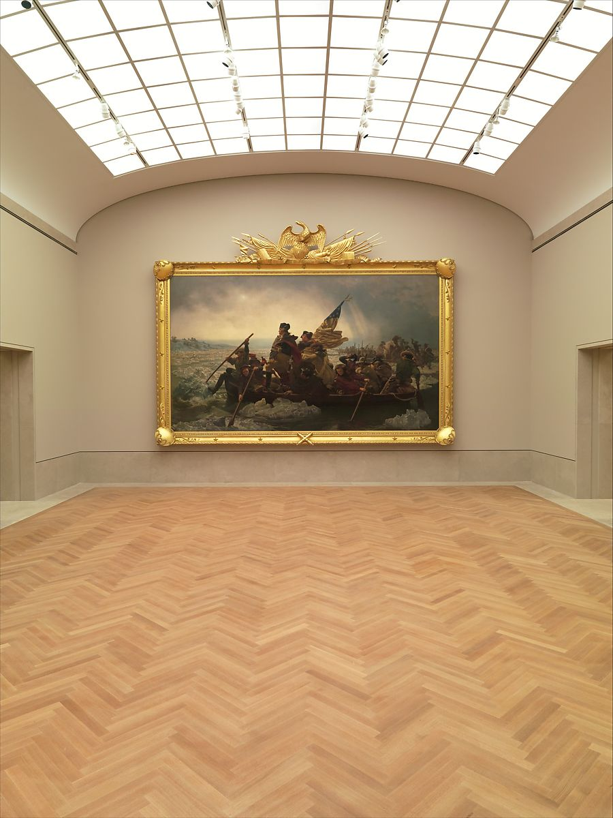
And this is actually the second of the of the three versions of Washington Crossing the Delaware that Leutze painted. The first version was destroyed during WWII and the third version used to hang in the West Wing of the White House, until it was moved to be on display at the Minnesota Marine Art Museum.
There are multiple renditions of this painting too.
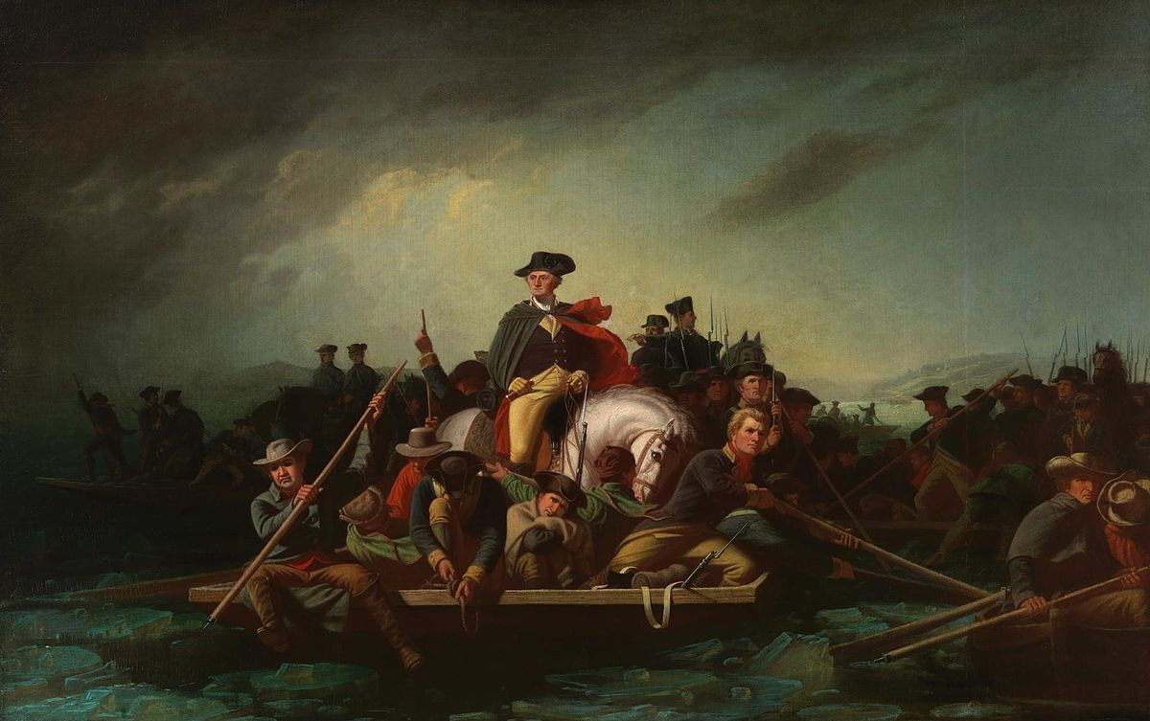
Washington Crossing the Delaware, by George Caleb Bingham, 1856–1871

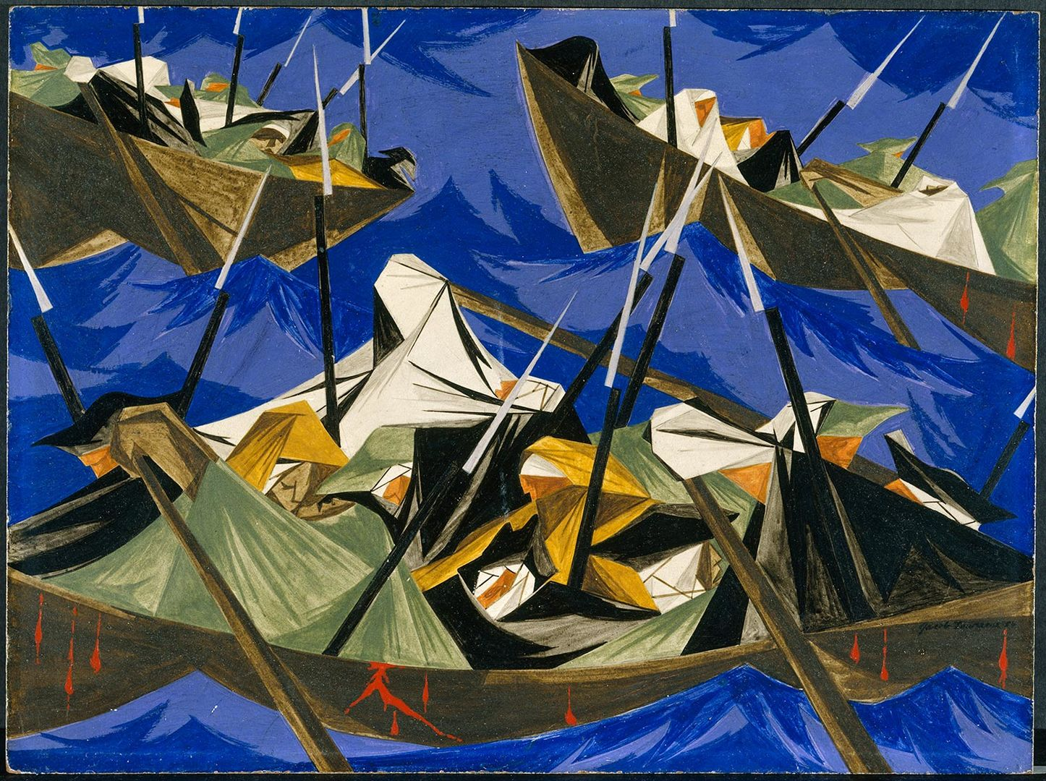
Struggle Series-No. 10: Washington Crossing the Delaware, by Jacob Lawrence, 1954
That’s it for this episode, if you’d like to learn more about Washington Crossing the Delaware by Emanuel Leutze, check out this article called “Washington Crossing the Delaware” written by James C. Harris, or if you want more in depth information, check the transcripts for additional resources. Thanks for listening.

