Welcome back to History through Art, I’m your host, Minjeong, and in this episode, we will be looking at a portrait of a French monarch, Louis XIV. As always, check the blog for images to go along with the podcast if you aren’t familiar with the artwork.
Starting off with a brief intro about the artist, this was painted in 1701 by a French painter named Hyacinth Rigaud. Rigaud lived during Louis XIVs reign and he painted a lot of other royal portraits including that of King Philip V of Spain and is said to have set the standard for the portrait for the Courts for centuries. He was very active; he painted around 400 paintings some of which were religious, and this one that we’re examining today of Louis the XIV is one of his most famous works.
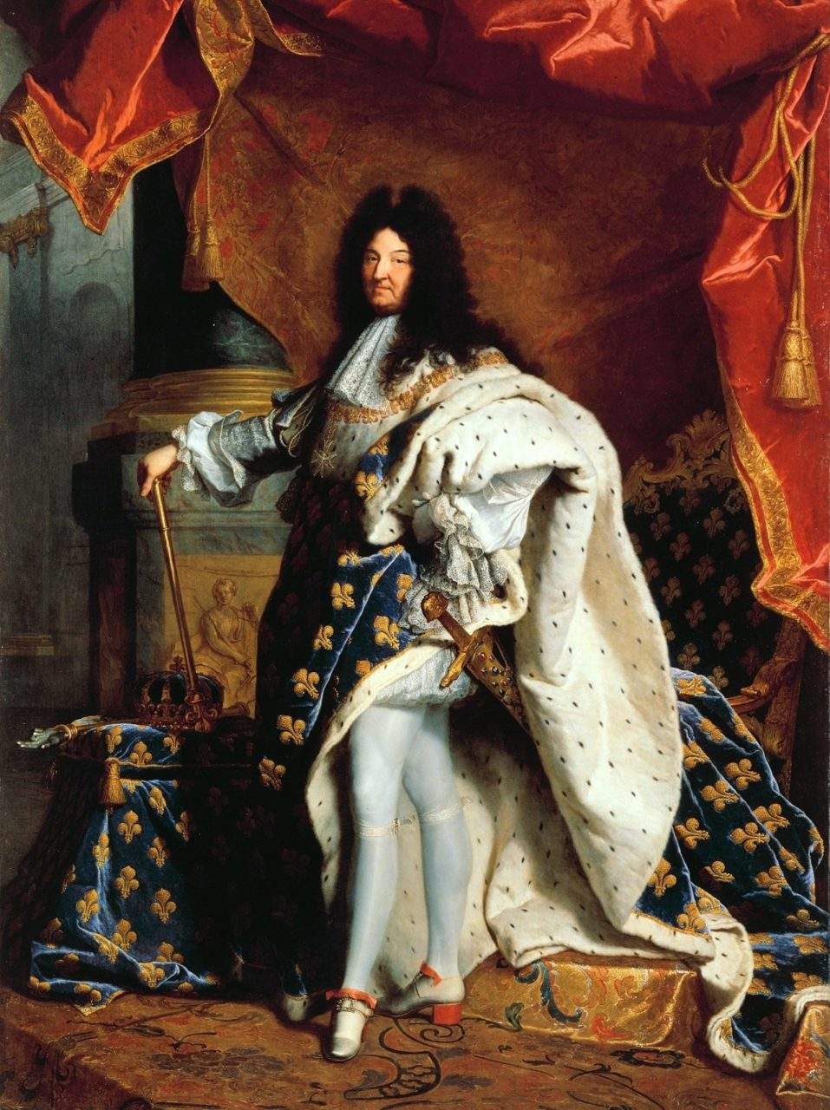
Now, moving onto the portrait itself, this painting was huge; it was life size at around 9 ft by 6 ft. And it was painted to be sent to Louis XIV’s grandson, Philip V of Spain as a diplomatic symbol and because King Philip wanted to take the image of his grandfather’s absolute royal power; but in the end, that never came through because of the war and other conflicts, so instead of this painting, a new painting was made of Louis the XIV in military uniform, and that was sent to King Philip V.
So now, let’s examine the painting. When we look portraits of leaders, we see what they’re wearing and what we see is what was considered to be fashionable at that time. What we have here is opulence, grandeur with the high wig and a lot of textures like velvet and fur. In European history, Louis XIV’s reign was in the Baroque period, and this period, in fashion, the trend was subdued luxury, so instead of flashy gems like diamonds, sapphires, and rubies, we have pearls, velvet, and satin; the materials that can reflect light subtly rather than brilliantly like it was before for a more elegant display of wealth. Light was a popular theme during the Baroque period; in art, the Baroque painter, Caravaggio was popular with his high contrast between the light and the dark in his paintings. And if you play classical music, we see that also with Baroque musicians Bach and Vivaldi.
So, in this painting, we see Louis XIV wearing his blue coronation robe with the gold fleur de lis pattern which is a symbol of French monarchy. He's carrying the royal sword on his waist and in his right hand he's caring royal scepter and right next to him is a crown, all of which reinforce his authority as a ruler. He's also wearing the red heeled shoes which was, at the time, only worn by the royals.
So the elements of this painting point to Louis XIV being a legitimate, confident ruler—looking at how he’s standing with his one foot out like that, he’s comfortable and at the time, he was 63 years old, and his face barely has any wrinkles, so he looks youthful and strong, very fit to rule.
A brief history of Louis XIV. His nickname is the Sun King, he reigned for 72 years and is probably one of the most well-known monarchs in European history. He was born in 1638, his father was Louis the 13th and mother was Anne of Austria; unfortunately, his parents weren't so close to each other, due to political reasons and also her struggling to produce an heir. His mother had four stillborns until she finally had Louis the 14th, hence his other name “Louis the God-given”. Two years after his birth, she gave birth to another son, and named him Philip.
Growing up, Louis XIV witnessed a lot of rebellions. Now, his dad died when he was only five years old, and because he was too young to rule, the country had this other guy who was the Chief Minister of France rule in place of him. Without power, at 22 years old in 1660, he unwilfully married Maria Theresa of Spain to symbolically put an end to the war France was in. And then a few months later, Louis was finally able to take his position back and in 1661, declared that he would not be appointing another Chief Minister, which at that time, that was an outrageous decision, which would have meant that he would become the absolute monarch of France.
In order to establish his position as the absolute ruler, he began portraying and comparing himself as Roman emperors and gods; he gave himself a nickname, the sun king. And actually, if you look at the painting, his posture doesn't seem as rigid or masculine like a military leader-- it almost looks more youthful with softer lines; his legs almost look like he's dancing, almost looks like he's dancing ballet; and it's because he did play ballet as a child and one of the roles that he played in one of the dances was the role of Apollo, the sun god.
So because France experienced a lot of rebellions--like 11 rebellions in 40 years or so-- Louis was determined to take control of the situation. He didn’t want anyone to rebel anymore, so the way that he was able to control was by keeping the nobles occupied with art and fashion at the Versailles.
The Palace of Versailles was completed around 20 km away from Paris which was far enough at the time considering that you can only travel on horses. The Palace was supposed to be like a center for where the nobles congregated, and Louis distracted the nobles by leading the latest fashion trends and having other high society activities like parties and gambling so that they would be too busy to plan any more rebellions.
And you might ask why would the nobles partake in Louis’ tea parties, and the reason was because Louis made this seem like an exclusive group; it was like being there that meant that you were an elite, you were part of the higher aristocrat, and one of ‘those’ people who could be near the king. It was like the closer you are to the King the closer you are to the power. Also, Louis favored and granted the nobles who supported him with their presence more than those who never showed up, so it became kind of like a competition to see who can suck up to him better.
So while Louis had control of nobles in his country there was also the consistent war that was going on against the Dutch and the Germans; this period in French history resulted in a very centralized, very powerful French monarchy, although, that only lasted a short time until the Napoleon led the French revolution in 1789 that overthrew Louis XVI.
Today, this painting hangs in the Louvre Museum in France. It’s actually never left France. Louis XIV was the longest reigning monarch in Europe, and definitely changed France in the most dramatic ways, like by extending the power of monarchs and the completing the Palace of Versailles and definitely contributed to the culture that spurred from there. In the present day, one direct influence of this period is evident in the fashion industry.
Alright, that’s it for this episode, if you’d like to learn more about Portrait of Louis XIV by Hyacinth Rigaud, check out this article called “1701 – Hyacinthe Rigaud, Louis XIV” written by Juyeon Kim or if you want more in depth information, check the transcripts for additional resources. Thanks for listening.

